
Social work and migration:
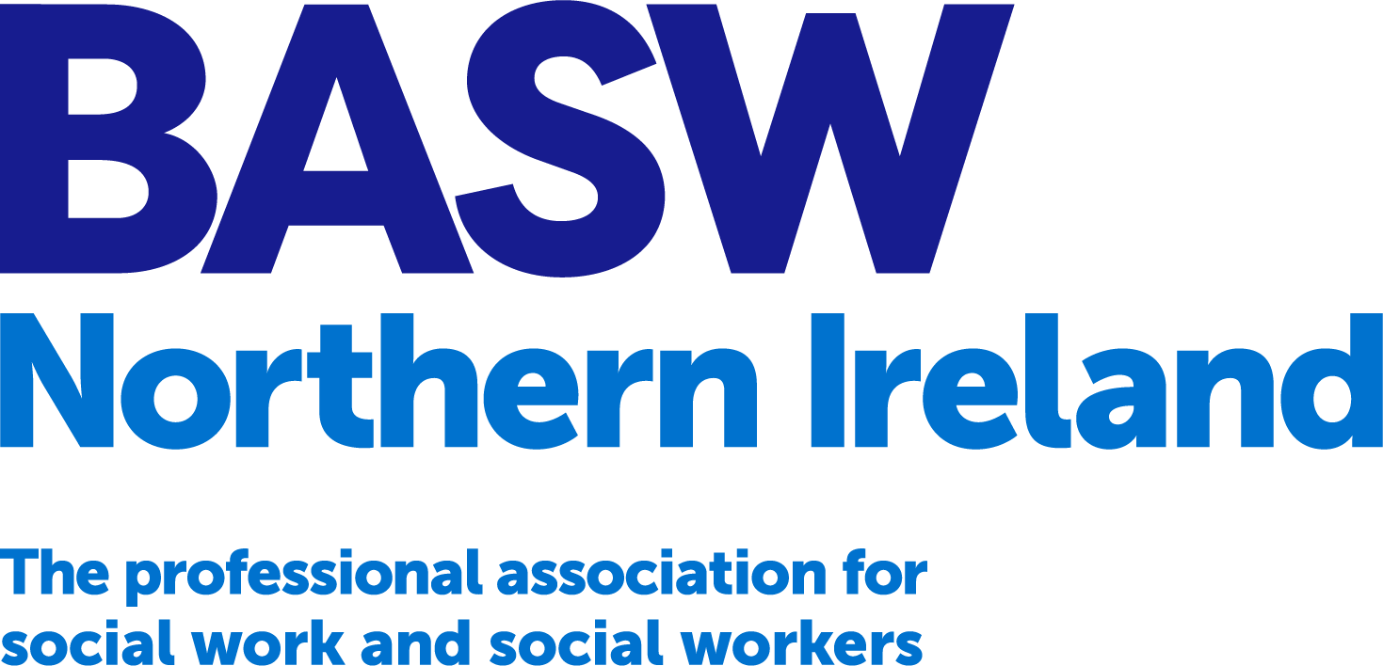
promoting social justice,
sustainability and human rights

Thursday 20 November 2025, Fairways Hotel, Dundalk
PROPOSAL FOR PRESENTATION
Presentation Title:
Contact details for lead presenter (email & phone number):
Names of presenters (including co-presenters)
Summary key points from presentation (150 words maximum):

Please email your completed template to n.ireland@basw.co.uk by Monday 7 April 2025.

