## Background

In March the Department for Education (DfE) announced a [consultation](https://consult.education.gov.uk/social-work-workforce-ecf-years-1-2/children-s-social-work-post-qualifying-standards-a/consultation/intro/) on their proposed shift from the current one year Assessed and Supported Year in Employment (ASYE) to:

* a two-year induction programme of development and self-assessment activities
* a new set of Post Qualifying Standards (PQS)

The new standards have been developed by an ***expert writing group****.* This group was led by a Director of Children’s Services and included front-line Social Workers, academics and experts in developing professional practice frameworks. The consultation outlines a five-year post-qualifying framework for Children’s Social Workers in England which will ‘focus on areas of specialism including child protection, practice supervision and leadership’.

The implementation is planned for autumn 2027 however this is subject to the allocation of funds following the Comprehensive Spending Review, expected in June 2025.

The consultation closes on the 28th May: see BASW Member actions below for details of how to respond.

## DfE Objectives of the PQS: Expected Benefits

The DfE state that these new standards will deliver the following benefits:

|  |  |
| --- | --- |
| **‘Benefit 1 – Quality of Practice**:’ | **‘Benefit 2 – Retention:** |
| **‘**The (Social Work Induction Programme) will improve the overall capacity of the workforce to deliver the outcomes of the National Framework by:   * Ensuring that all social workers access consistent development within the first two years of entering the profession * increasing the average experience of the profession (link to benefit 2)’ | By providing additional development to help social workers develop confidence and competence more quickly, and by providing additional support to manage work during this time, we will reduce early career attrition.’ |
| Source: DfE Webinar presentation, 2.4.25 | |

## Overview of the Standards

The PQS is made up of six domains ‘reflecting key aspects of social work with children’:

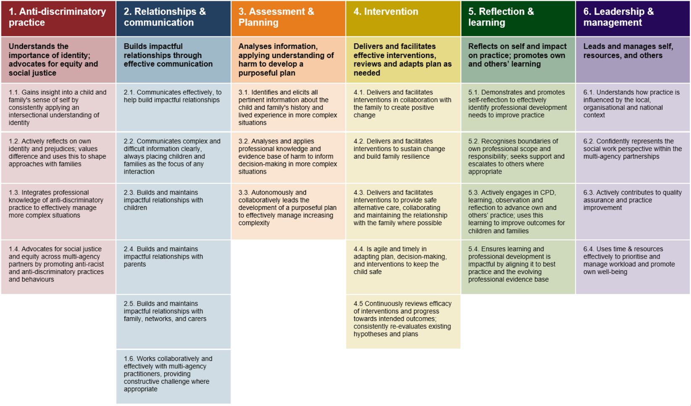

Source: DfE Webinar presentation, 2.4.25

Each domain has between three and six **outcome statements**, as shown in the table from the DfE above. Each Outcome Statement is supported by several **‘knows’** and **‘does’** statements. In total there are 199 ‘knows’ and 169 ‘does’ statements. For full details see the resources section below.

The DfE states that Anti-Discriminatory Practice is *‘fundamental to all areas of social work practice’* so will need to be considered and demonstrated within all the other five domains.

At their open briefing session on 2nd April, the DfE said that Social Workers will be expected to provide evidence that the have met each of the 26 outcomes statements, but that they do not have to provide evidence to support each of the 368 ‘knows’ and ‘does’ statements. Instead, Social Workers should use the 368 ‘knows’ and ‘does’ statements as prompts to shape their self-assessment and evidence gathering.

## Initial views on the proposals

Subject to the qualifications below, members who have spoken to BASW are broadly supportive of the standards and the ambitions expressed by the DfE for this programme and welcome the focus on ensuring that Social Workers receive appropriate support to develop their knowledge and skills during the early stages of their career.

The BASW England Children and Families Thematic Group and other members who have spoken to BASW England have told us that:

* the standards focus on the specific role of Social Workers in specialist child protection teams
* there is little read across from these standards to the roles newly qualified social workers play in a variety of other teams, such as Early Help and Child in Need in a local authority, CAMHS and other NHS teams or Social Workers in the Voluntary and Community Sector
* there is no explanation as to how these standards interact with other frameworks such as the Professional Capabilities Framework (PCF) or similar standards developed by Social Work England.
* the large number of ‘knows’ and ‘does’ statements may make it confusing for Social Workers who are completing their ‘induction’ and try to evidence every single statement. Clear guidance on this will be vital.
* there is a concern that the vital specialist modules required by Social Workers after their induction may:
  + not be completed due to resource constraints in the DfE
  + not cover the full spectrum of specialist roles undertaken by Social Workers with children & families, such as Fostering, Adoption, Disabled Children, Early Help and preventative work, in addition to the areas already identified such as ‘child protection, practice supervision and leadership’.

BASW England note that Global Majority Social Workers and Neurodivergent Social Workers have reported experiencing prejudice within the current one year ASYE programme, making it less likely that they are able to complete their ASYE on time or even at all. BASW England would therefore be interested to see the DfE’s Equality Impact Assessment to help understand how the DfE are mitigating what is likely to be an increased risk of disproportionate treatment within a two year programme.

## DfE and BASW Events

The DfE are holding a second webinar to introduce the PQS and Induction proposal. This is on the 7th May and you can [book a place here](https://events.teams.microsoft.com/event/ed80c65c-1e31-48ba-a55c-f0fb3a975ecc@fad277c9-c60a-4da1-b5f3-b3b8b34a82f9) (open the link and click the register button)

BASW England are holding a focus group for members on the 8th May. This will support BASW England to gather views from members before responding to the consultation and [BASW Members can book a place here](https://basw.co.uk/events/basw-england-focus-group-proposed-post-qualifying-standards-children-families-social-workers)

## BASW Member actions

As well as joining one or both of the events above, members are recommended to respond to the consultation as individuals: there is a link to the [consultation questionnaire here](https://consult.education.gov.uk/social-work-workforce-ecf-years-1-2/children-s-social-work-post-qualifying-standards-a/consultation/intro/)

You can also respond directly to the consultation via this e-mail address: [pqs.consultation@education.gov.uk](mailto:pqs.consultation@education.gov.uk)

## Documents and Resources

[Post-qualifying standards and induction for child and family social workers: Government consultation](https://consult.education.gov.uk/social-work-workforce-ecf-years-1-2/children-s-social-work-post-qualifying-standards-a/supporting_documents/Postqualifying%20standards%20and%20induction%20for%20child%20and%20family%20social%20workers%20consultation.pdf)

[Post-qualifying standards: knowledge and skills statement for child and family practitioners](https://consult.education.gov.uk/social-work-workforce-ecf-years-1-2/children-s-social-work-post-qualifying-standards-a/supporting_documents/Postqualifying%20standards%20March%202025.pdf)

[DfE Consultation Webpage](https://consult.education.gov.uk/social-work-workforce-ecf-years-1-2/children-s-social-work-post-qualifying-standards-a/supporting_documents/Postqualifying%20standards%20March%202025.pdf)